**Build Instructions**

**Software Requirements**

1. Macintosh OSX based computer running 10.7 or later
2. XCode 7.0 IDE with iOS SDK
3. Virtual_Classroom Source file

# Instructions

1. Unzip the Virtual_Classroom.zip source file into a designated folder
2. Open XCode. In the main screen, click “Open another project…” at the bottom right corner of the screen.

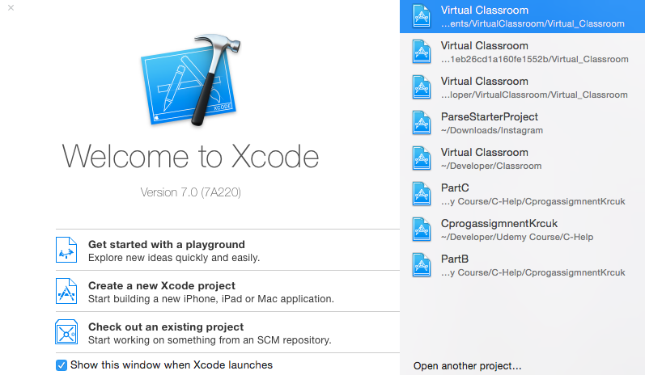

1. A file selection box will appear. Navigate to the location of the Virtual_Classroom folder created in step 1.
2. Select the “Virtual Classroom.xcodeproj” file and click open.

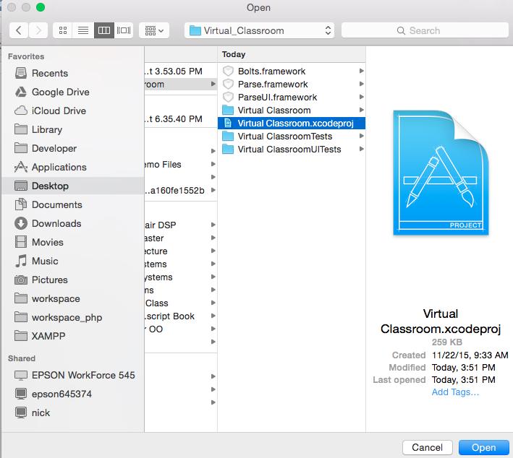

1. XCode will load all of the files and library dependencies into the project workspace. This may take a few minutes for XCode to finish indexing and processing all of the files.
2. Click the “Build and Run” button at the top left of the window to build and run the program.

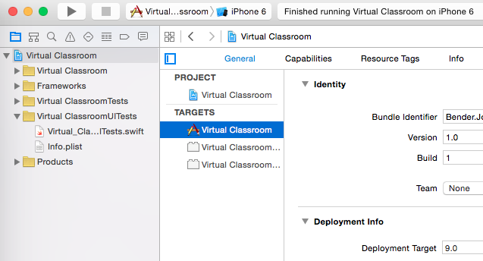

Please Note: if the current version of XCode is older than XCode 7, please be sure to update to the most current version of XCode to properly run the program. If the version of XCode is newer than 7.0, please change the Base SDK option to the current version of XCode that you are running. Lastly, please set the simulator scheme to run on the iOS simulator for iPhone 6 (shown below).

